**User Documentation**

## Start Hyperspace Cheese Battle

To start the game simply open the game package and double click the icon named “Hyperspace Cheese Battle”.



It will open a black window similar to the one that you can see below.

You can drag the window to move it around and resize it to get a better view of all the game.

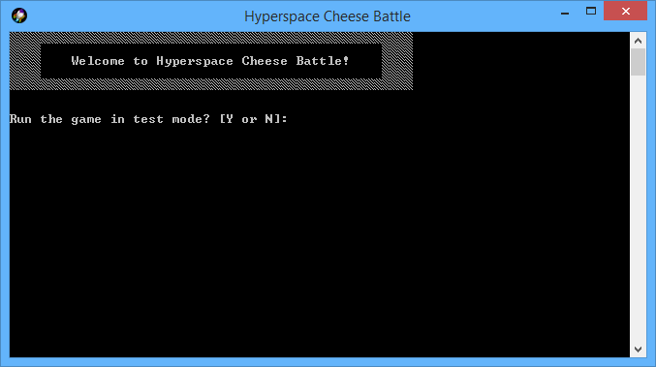

# Start playing

The game will ask if you would like to run it in Test Mode, which is a nice way to understand all the game mechanics.

If you want to go straight to the game press “N” and start playing in normal mode.

Follow the in-game instructions to insert the number of players (you can play with two, three or four people) and their names.

The main objective of the game is to reach the final Hyperspace square before everyone else, you can move your rocket on the board by rolling the dice and following the board directions.

The game will start with the first player’s turn and it will loop until a player will arrive to the top right square of the board.

# The game board

This is the board that you will be using in the game.

As you can see it is an 8x8 board where the players will move by following the arrows directions.

All the players will start at the position (0, 0), and the game will end as soon as one player manages to arrive to the position (7, 7).

The yellow arrows indicate the Cheese Power Squares.

# Board limits and Collisions

The rockets were studied to travel only in the known Hyperspace, trying to go beyond the board limit will make the rocket staying still in the same position for that round.

It is very likely that the Hyperspace flow brings the rockets in the same zone, and probably some collisions may occur.

This means that if a player is landing on an enemy, he will be bounced on the next free square available.



# Cheese Power

Whenever a player lands on a Cheese Power Square (marked on the board by the yellow arrows), he will have the chance to throw the dice again or to attack another player.

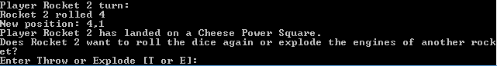

Follow the instructions in-game to master the Cheese Power.

# Six Power

The Six Power ability is used each time a player gets a six from a dice roll.

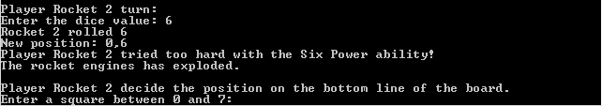This power has three stages, basically you can keep rolling the dice as long as you roll six, but at the third time in a row that you use the power (e.g. player rolled 6, 6, 6), the player’s engine will explode and bring him back to the bottom line of the board.

It might happen to land on a Cheese Power Square while using the Six Power ability.

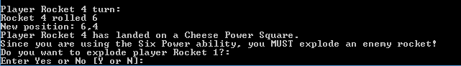That creates a combo of powers and forces the player to attack an enemy before continuing to use the Six Power ability.

Follow the instructions in-game to master the Six Power.

# End game

Finally when a player manages to reach the final square, the game will end.

You will still be able to scroll up the game window to check what happened in the last rounds and of course you can start another game to seek revenge in case you were not the winner!

# Extras – Test Mode

At the start of each game you could decide to try the Test Mode too, which is a nice way to understand all the game mechanics.



This also might be useful to learn which square in the bottom line of the board is the best to restart from after an explosion.

You can choose which dice to use, between Preset, Choose and Random methods.

The best way to check all the options is to test all while in-game, at a point it might become even more interesting than the game itself!